training 1 epoch...

53.8752167224884 seconds used......

1 training finished! average train loss: 0.6809622136908665

evaluating...

Confusion matrix, without normalization

[[ 237 38 19]

[ 990 2742 89]

[ 88 13 741]]

Normalized confusion matrix

[[0.80612245 0.1292517 0.06462585]

[0.25909448 0.71761319 0.02329233]

[0.10451306 0.01543943 0.88004751]]

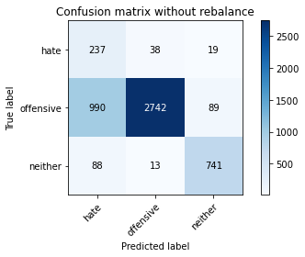

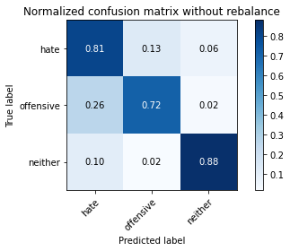

precision recall f1-score support

hate 0.18 0.81 0.29 294

offensive 0.98 0.72 0.83 3821

neither 0.87 0.88 0.88 842

accuracy 0.75 4957

macro avg 0.68 0.80 0.67 4957

weighted avg 0.92 0.75 0.81 4957

average eval_loss: 0.5563150661859627, accuracy: 0.7504539035707081

training 2 epoch...

53.16596555709839 seconds used......

2 training finished! average train loss: 0.38581746225163605

evaluating...

Confusion matrix, without normalization

[[ 261 23 10]

[1344 2394 83]

[ 104 11 727]]

Normalized confusion matrix

[[0.8877551 0.07823129 0.03401361]

[0.35174038 0.62653756 0.02172206]

[0.12351544 0.01306413 0.86342043]]

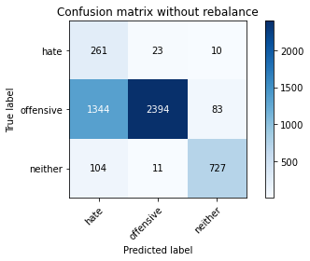

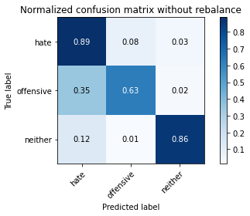

precision recall f1-score support

hate 0.15 0.89 0.26 294

offensive 0.99 0.63 0.77 3821

neither 0.89 0.86 0.87 842

accuracy 0.68 4957

macro avg 0.68 0.79 0.63 4957

weighted avg 0.92 0.68 0.75 4957

average eval_loss: 0.6885932352382611, accuracy: 0.6822675005043373

training 3 epoch...

53.20176029205322 seconds used......

3 training finished! average train loss: 0.2618486427358891

evaluating...

Confusion matrix, without normalization

[[ 235 45 14]

[ 829 2901 91]

[ 59 22 761]]

Normalized confusion matrix

[[0.79931973 0.15306122 0.04761905]

[0.21695891 0.75922533 0.02381576]

[0.07007126 0.02612827 0.90380048]]

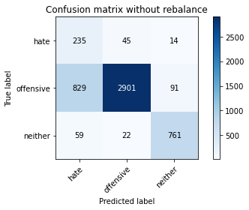

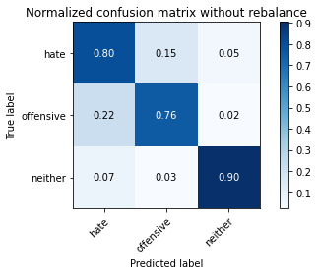

precision recall f1-score support

hate 0.21 0.80 0.33 294

offensive 0.98 0.76 0.85 3821

neither 0.88 0.90 0.89 842

accuracy 0.79 4957

macro avg 0.69 0.82 0.69 4957

weighted avg 0.92 0.79 0.83 4957

average eval_loss: 0.49942389001163834, accuracy: 0.7861609844664111

training 4 epoch...

53.11346483230591 seconds used......

4 training finished! average train loss: 0.16900335985088819

evaluating...

Confusion matrix, without normalization

[[ 242 34 18]

[1166 2556 99]

[ 43 44 755]]

Normalized confusion matrix

[[0.82312925 0.11564626 0.06122449]

[0.30515572 0.66893483 0.02590945]

[0.05106888 0.05225653 0.89667458]]

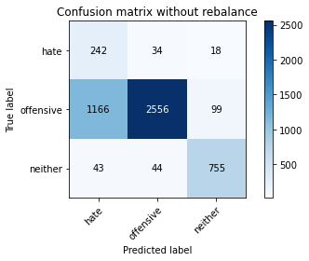

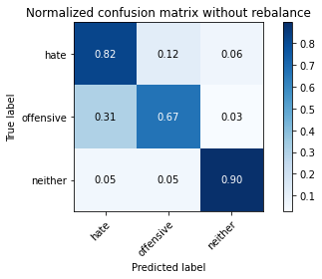

precision recall f1-score support

hate 0.17 0.82 0.28 294

offensive 0.97 0.67 0.79 3821

neither 0.87 0.90 0.88 842

accuracy 0.72 4957

macro avg 0.67 0.80 0.65 4957

weighted avg 0.90 0.72 0.78 4957

average eval_loss: 0.8101637823664755, accuracy: 0.7167641718781521

training 5 epoch...

53.47605061531067 seconds used......

5 training finished! average train loss: 0.10054439292371012

evaluating...

Confusion matrix, without normalization

[[ 231 49 14]

[ 793 2919 109]

[ 50 33 759]]

Normalized confusion matrix

[[0.78571429 0.16666667 0.04761905]

[0.20753729 0.76393614 0.02852656]

[0.05938242 0.0391924 0.90142518]]

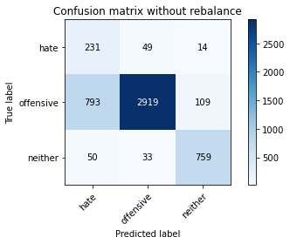

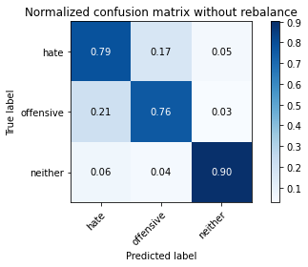

precision recall f1-score support

hate 0.22 0.79 0.34 294

offensive 0.97 0.76 0.86 3821

neither 0.86 0.90 0.88 842

accuracy 0.79 4957

macro avg 0.68 0.82 0.69 4957

weighted avg 0.91 0.79 0.83 4957

average eval_loss: 0.7364303231706387, accuracy: 0.7885818035101876

training 6 epoch...

53.30102181434631 seconds used......

6 training finished! average train loss: 0.06190436358436975

evaluating...

Confusion matrix, without normalization

[[ 266 20 8]

[1546 2213 62]

[ 155 28 659]]

Normalized confusion matrix

[[0.9047619 0.06802721 0.02721088]

[0.40460612 0.57916776 0.01622612]

[0.18408551 0.03325416 0.78266033]]

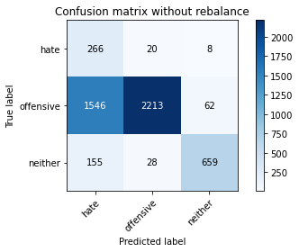

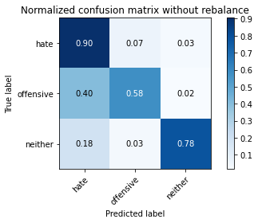

precision recall f1-score support

hate 0.14 0.90 0.24 294

offensive 0.98 0.58 0.73 3821

neither 0.90 0.78 0.84 842

accuracy 0.63 4957

macro avg 0.67 0.76 0.60 4957

weighted avg 0.92 0.63 0.72 4957

average eval_loss: 1.6602151271017702, accuracy: 0.6330441799475489

training 7 epoch...

53.1301326751709 seconds used......

7 training finished! average train loss: 0.04437178428736189

evaluating...

Confusion matrix, without normalization

[[ 223 56 15]

[ 789 2914 118]

[ 54 27 761]]

Normalized confusion matrix

[[0.7585034 0.19047619 0.05102041]

[0.20649045 0.76262758 0.03088197]

[0.06413302 0.03206651 0.90380048]]

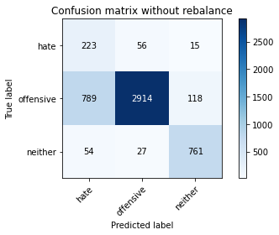

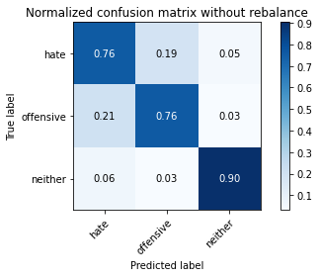

precision recall f1-score support

hate 0.21 0.76 0.33 294

offensive 0.97 0.76 0.85 3821

neither 0.85 0.90 0.88 842

accuracy 0.79 4957

macro avg 0.68 0.81 0.69 4957

weighted avg 0.91 0.79 0.83 4957

average eval_loss: 1.0407697942925285, accuracy: 0.7863627193867259

training 8 epoch...

53.096540212631226 seconds used......

8 training finished! average train loss: 0.0547612547346497

evaluating...

Confusion matrix, without normalization

[[ 219 61 14]

[ 697 3031 93]

[ 55 42 745]]

Normalized confusion matrix

[[0.74489796 0.20748299 0.04761905]

[0.18241298 0.79324784 0.02433918]

[0.06532067 0.04988124 0.8847981 ]]

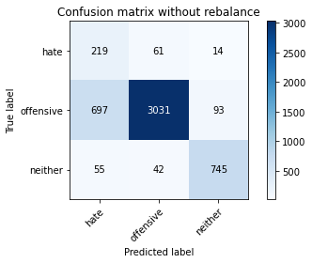

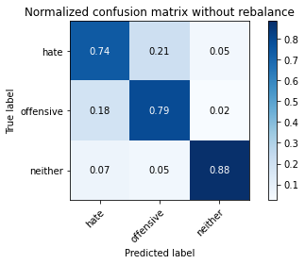

precision recall f1-score support

hate 0.23 0.74 0.35 294

offensive 0.97 0.79 0.87 3821

neither 0.87 0.88 0.88 842

accuracy 0.81 4957

macro avg 0.69 0.81 0.70 4957

weighted avg 0.91 0.81 0.84 4957

average eval_loss: 0.860393819123439, accuracy: 0.8059310066572524

training 9 epoch...

53.14708209037781 seconds used......

9 training finished! average train loss: 0.021432524798448163

evaluating...

Confusion matrix, without normalization

[[ 205 70 19]

[ 549 3113 159]

[ 37 13 792]]

Normalized confusion matrix

[[0.69727891 0.23809524 0.06462585]

[0.14367967 0.81470819 0.04161214]

[0.04394299 0.01543943 0.94061758]]

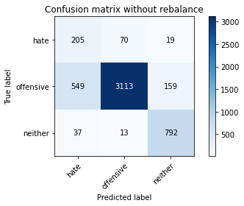

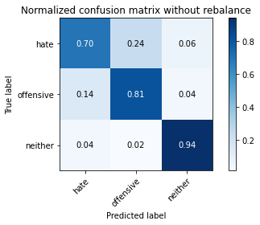

precision recall f1-score support

hate 0.26 0.70 0.38 294

offensive 0.97 0.81 0.89 3821

neither 0.82 0.94 0.87 842

accuracy 0.83 4957

macro avg 0.68 0.82 0.71 4957

weighted avg 0.90 0.83 0.85 4957

average eval_loss: 0.8605223982902652, accuracy: 0.8291305224934437

training 10 epoch...

53.08567452430725 seconds used......

10 training finished! average train loss: 0.03052985422918777

evaluating...

Confusion matrix, without normalization

[[ 235 42 17]

[ 930 2804 87]

[ 56 38 748]]

Normalized confusion matrix

[[0.79931973 0.14285714 0.05782313]

[0.24339178 0.73383931 0.02276891]

[0.06650831 0.04513064 0.88836105]]

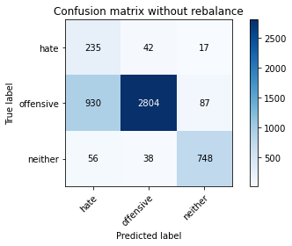

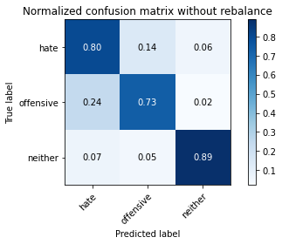

precision recall f1-score support

hate 0.19 0.80 0.31 294

offensive 0.97 0.73 0.84 3821

neither 0.88 0.89 0.88 842

accuracy 0.76 4957

macro avg 0.68 0.81 0.68 4957

weighted avg 0.91 0.76 0.81 4957

average eval_loss: 1.1675729269223019, accuracy: 0.7639701432317935